Transatlantic Roundtable

Europe in the Shadow of America?
Prospects for CFSP/ESDP

Agenda

July 17/18, 2003

Residence Palace
155, Rue de la Loi
Brussels

Center for Applied Policy Research (C.A.P)
Maria-Theresia-Str. 21
D-81675 Munich
Tel.: **49-89-2180 1300
Fax.: **49-89-2180 1329

The European Policy Centre
Residence Palace
155, Rue de la Loi
B-1040 Brussels
Tel.: *32-2-231 03 40
Fax.: *32-2-231 07 04

The Center for Applied Policy Research would like to thank the German Marshall Fund of the U.S. for the generous support of its transatlantic roundtable program

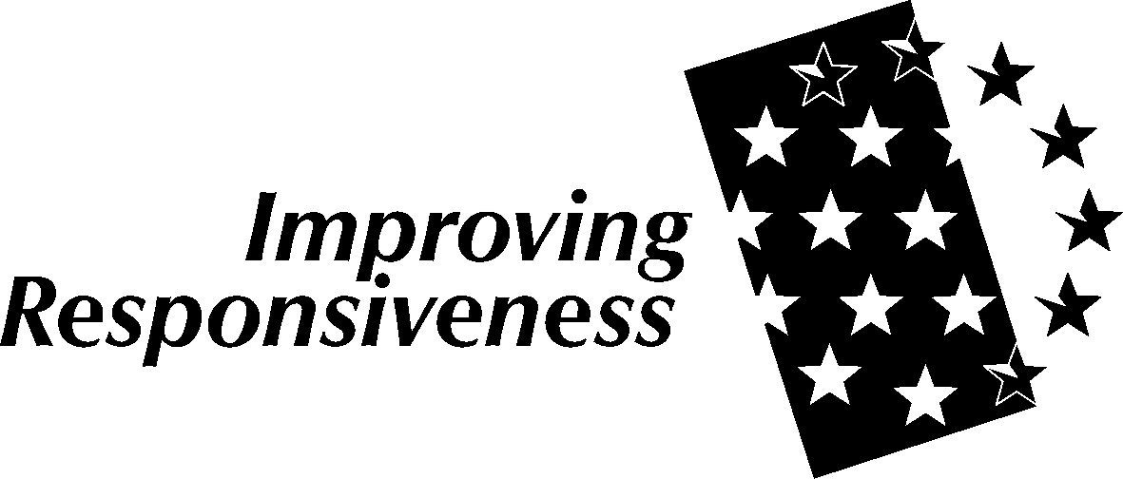

July 17, 2003

2:30 p.m. | Welcome and Introduction  Fraser Cameron  Director of Studies  The European Policy Center, Brussels  Wolfgang Bücherl  Director of the Project Improving Responsiveness  Center for Applied Policy Research, Munich
2:45 p.m. | CFSP/ESDP reform in light of the Convention and the Iraq debate  An evaluation of institutional structures.  Chair:  John Palmer  Political Director  The European Policy Center, Brussels  Introductory statements:  Franco Algieri  Director of the CFSP-Project  Center for Applied Policy Research, Munich  Fraser Cameron  Director of Studies  The European Policy Center, Brussels  Discussion
4:00 p.m. | Coffee/Break

4:30 p.m.  - 6:30 p.m. | CFSP/ESDP in practice  Case studies of EU Missions (Bosnia-Hercegovina, Macedonia).  Chair:  Franco Algieri  Director of the CFSP-Project  Center for Applied Policy Research, Munich  Introductory statements:  Michael Matthiessen  Director  Directorate for Civilian Crisis Management, Council of the European Union  Mihai Carp  Acting Head  Cooperative Security and Political Crisis Management Section (CSCM)  Political Affairs Division  NATO Headquarters  Discussion
7: 00 p.m. | Dinner  Does the US want a strong Europe?  Dinner Speaker:  Bill Drozdiak  Director, Transatlantic Center, The German Marshall Fund of the U.S., Brussels

July 18, 2003

9:00 a.m. | CFSP/ESDP and enlargement  The new member states between acceptance of the acquis and  distinctive national interests.  Chair:  Hüseyin Bagci  Professor  Middle East Technical University, Ankara  Introductory statements:  Pawel Swieboda  Director  Department of the European Union, Ministry of Foreign Affairs, Warsaw  Julian Lindley-French  Director, European Security Policy TC  Geneva Centre for Security Policy  Discussion
10:30 a.m. | Coffee Break
11:00 a.m. | CFSP/ESDP and the US  Shared strategic security interests and the corresponding forums.  Chair:  John van Oudenaren  Chief, European Division  Library of Congress, Washington D.C.  Introductory statements:  Joseph Manso  Political Officer  U.S. Mission to NATO  Kornelis van Rij  Advisor  Council of the European Union  Comment:  Barry Posen  Fellow, The German Marshall Fund of the U.S.  Transatlantic Center, Brussels  Discussion
12:45 p.m. | Lunch/ End of Conference

